Assignment IX: Numerical Integration Using Real-World Data
Dataset: Temperature (Telemetry Hourly), CWPRS — Maharashtra (2021–2025)
Source: India National Water Data Portal (NWDP)

1. Aim
To apply the composite Trapezoidal Rule, composite Simpson’s 1/3 Rule, and composite Simpson’s 3/8 Rule to a real temperature time series downloaded from India’s National Water Data Portal, and compare the resulting estimates.

2. Data source and data inspection
The source dataset is titled “Temperature (Telemetry Hourly), CWPRS” and is published on the National Water Data Portal. The supplied CSV contains CWPRS campus records in Pune, Maharashtra, with a timestamp and air-temperature measurement. Although the dataset title includes “Hourly,” inspection of the actual timestamps in this downloaded file shows that the records are predominantly spaced five minutes apart. Therefore, the calculations use the observed five-minute interval rather than assuming hourly spacing.
The file contains 87,990 rows and 1 station label(s). The usable data were parsed, sorted by timestamp, numeric temperatures retained, missing timestamp/temperature rows removed, and duplicate timestamps dropped. To avoid integrating across gaps, the analysis uses the first 289 samples from the longest uninterrupted five-minute run.
Selected station: CWPRS campus; district: Pune; coordinates: 18.446944° N, 73.785000° E.
Selected time interval: 2025-01-16 11:05:00 to 2025-01-17 11:05:00. It contains 289 samples and 288 equal subintervals. The step size is h = 5 minutes = 0.083333 hour, giving a total duration of 24.0 hours.

3. Mathematical methods
Let yᵢ be the measured temperature at equally spaced time tᵢ, with spacing h measured in hours.

3.1 Composite Trapezoidal Rule
I ≈ h [y₀/2 + y₁ + y₂ + … + yₙ₋₁ + yₙ/2].
This approximates each pair of samples by a straight line and sums the trapezoid areas.

3.2 Composite Simpson’s 1/3 Rule
I ≈ (h/3) [y₀ + yₙ + 4Σ(yᵢ for odd i) + 2Σ(yᵢ for even interior i)].
The number of subintervals must be even. Here n = 288, so the rule is applicable.

3.3 Composite Simpson’s 3/8 Rule
I ≈ (3h/8) [y₀ + yₙ + 3Σ(yᵢ where i is not a multiple of 3) + 2Σ(yᵢ where i is a multiple of 3, excluding endpoints)].
The number of subintervals must be divisible by 3. Here n = 288, which is divisible by 3, so the rule is applicable.

4. Results
Method | Integral estimate (°C·h) | Applicable?
Composite Trapezoidal | 556.383333 | Yes
Composite Simpson 1/3 | 556.238889 | Yes
Composite Simpson 3/8 | 556.434375 | Yes
The integral has units °C·h (degree-Celsius hours), because temperature in °C is integrated over time in hours. It represents the accumulated temperature over the selected interval, not energy or a temperature value at one instant.
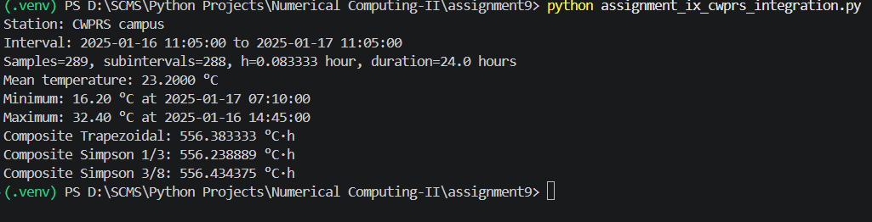
Descriptive statistics for this interval: mean = 23.200 °C, minimum = 16.20 °C at 2025-01-17 07:10:00, maximum = 32.40 °C at 2025-01-16 14:45:00.
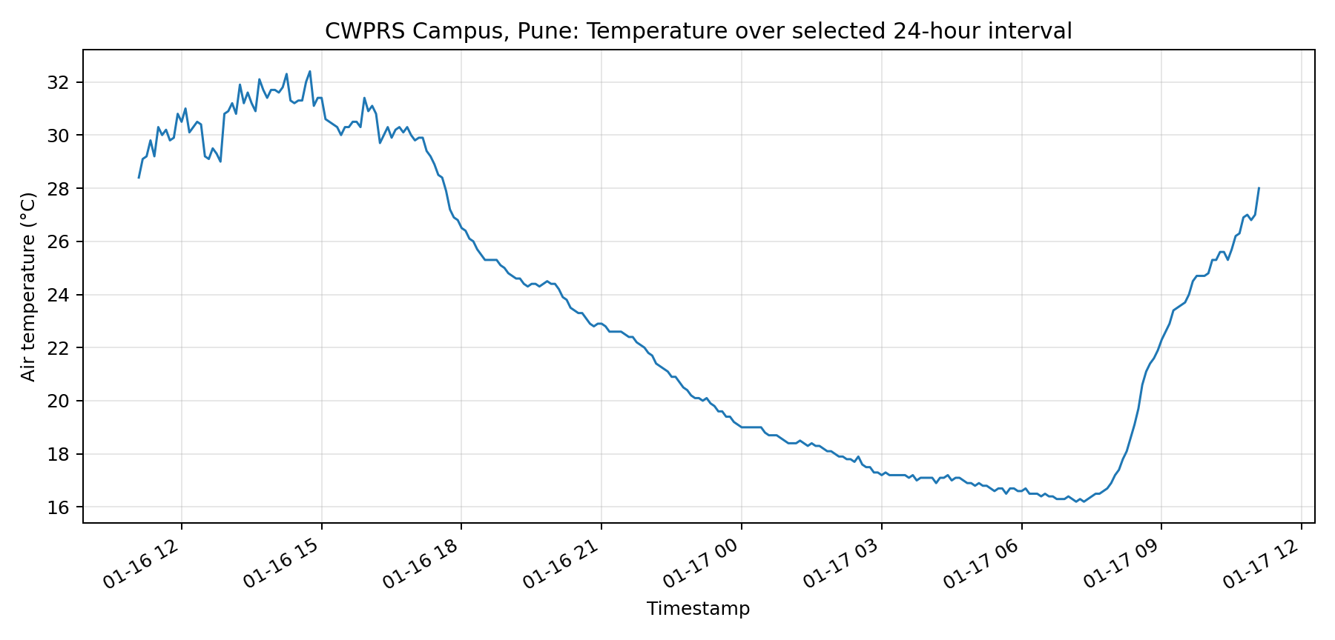
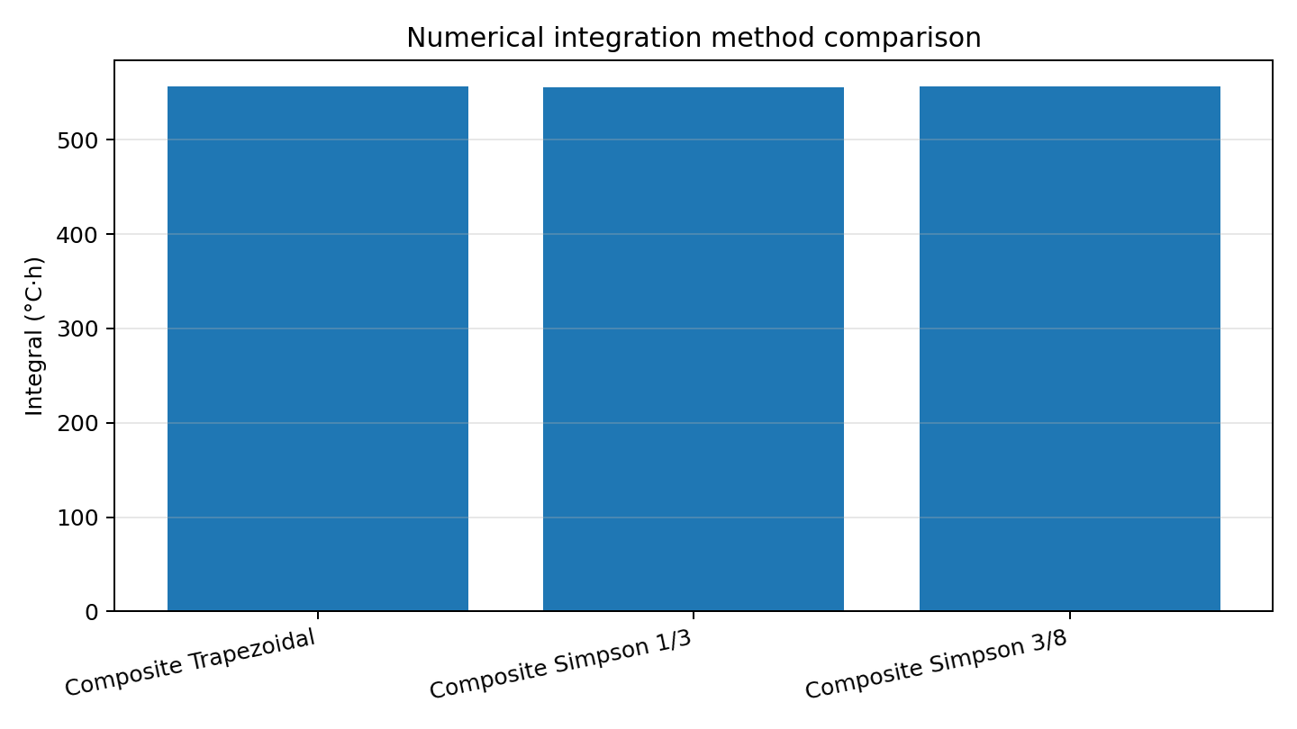

5. Discussion
All three composite methods can be applied because the selected data have equal five-minute spacing and 288 subintervals. The Trapezoidal Rule uses linear segments. Simpson’s rules use quadratic- or cubic-based weighting patterns and often provide higher accuracy for sufficiently smooth functions. Temperature readings are empirical measurements and may contain sensor noise or abrupt changes, so the difference between the estimates should be interpreted as a method comparison, not as proof that one estimate is the exact answer.
Consequently, a true absolute error cannot be calculated from the supplied observations alone.

6. Data quality and limitations
The dataset’s title says “Hourly,” but the supplied CSV contains many timestamps at five-minute intervals. The timestamp spacing was verified from the data, and the observed five-minute interval was used for h. Missing timestamps were not interpolated: only a contiguous sequence with exactly five-minute gaps was selected. This keeps the integration grid uniform, which is required by the composite formulas used here.
A different valid window can produce different integral estimates.

7. Conclusion
Using the NWDP CWPRS campus temperature data, the estimated accumulated temperature over the selected 24-hour period is 556.383333 °C·h by the composite Trapezoidal Rule, 556.238889 °C·h by Simpson’s 1/3 Rule, and 556.434375 °C·h by Simpson’s 3/8 Rule. The methods can be compared on equal footing because they use the same 288 subintervals. Without a known exact integral, the comparison does not establish the true error of any method.
Required packages: pandas, numpy, matplotlib. Install with: pip install pandas numpy matplotlib

References
National Water Data Portal, “Temperature (Telemetry Hourly), CWPRS,” resource: Temprature CWPRS Maharashtra (2021–2025) Telemetry Hourly CSV.
https://nwdp.nwic.gov.in/en/dataset/temperature-telemetry-hourly-cwprs
Required packages: pandas, numpy, matplotlib. Install with: pip install pandas numpy matplotlib
Submitted by,
Khumba Lunganlung

